NAME: ANIRUDH NAGARAJAN

SRN: PES2UG24CS065

SECTION: B

INITIAL CODE COVERAGE:
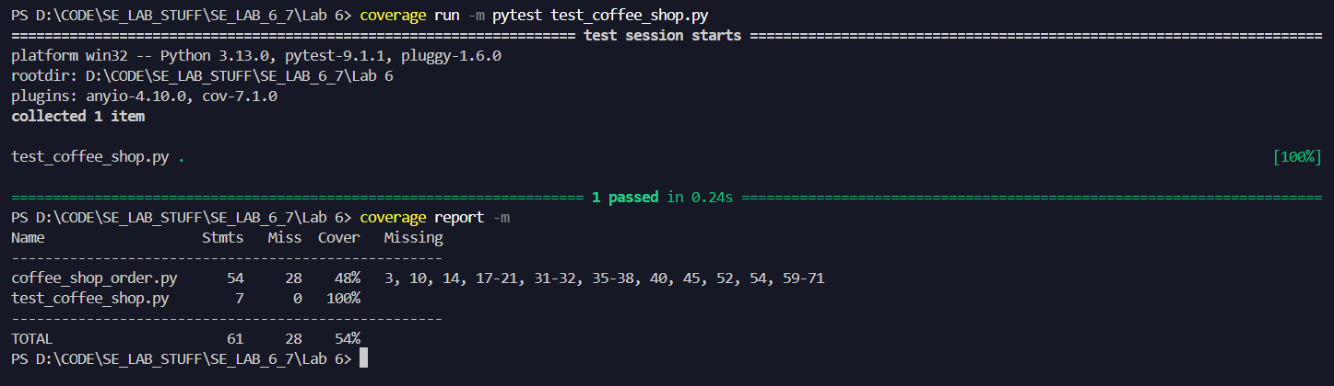

ADDED 8 EXTRA TEST CASES:
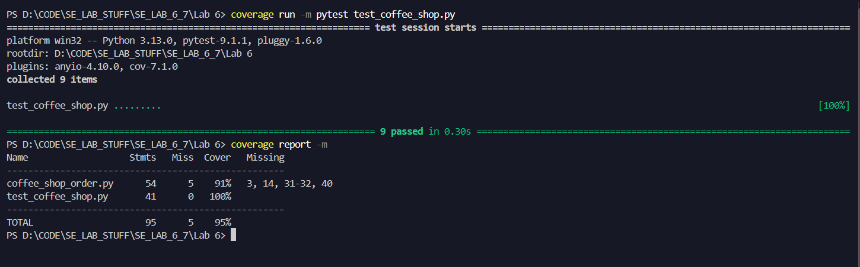

INITIAL BRANCH COVERAGE:
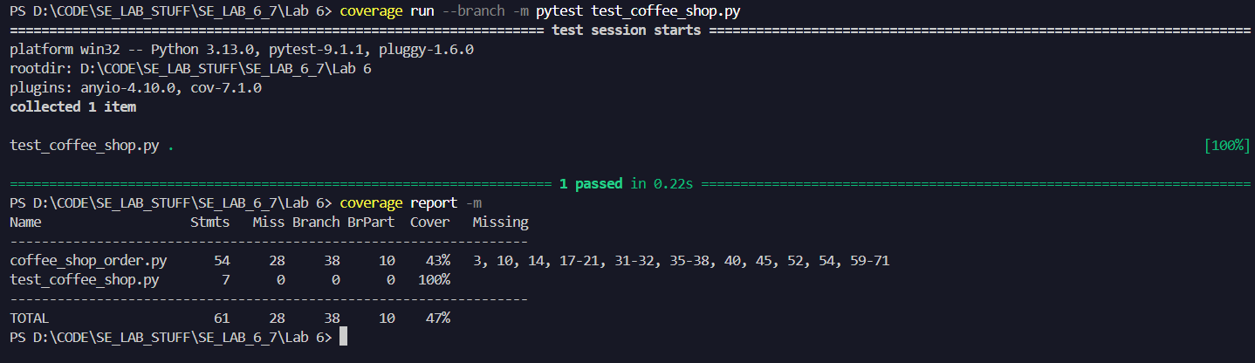

FROM CODE COVERAGE CASES:
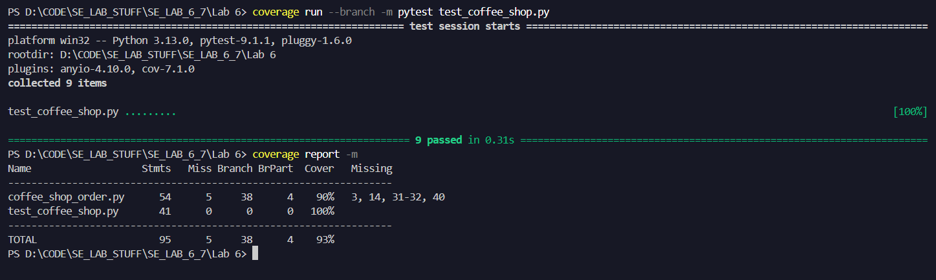
Obtained the required 90% branch coverage by using the test cases for code coverage as they already cover most of the if-else, for loop branches.

